# OSC1Lite board testing procedure

# Visually inspect all solder pads

Look at all solder pads and look for short or fall off components. Pay extra attention to components with small pinouts (isolator, DAC, and 2 Amps in the boost circuit, omnetics connector) and the connectors to FPGA. Use the continuity (beep when short) mode of a multimeter if in doubt.

# Test important voltages

## Power the board using DC power supply

Use a DC power source to supply 7.4V to the connector on the bottom right, or the battery holder. Limit the max current to 0.5A. Turn on the board switch. The current should be 0.17A typically, and not above 0.3A. The LEDs beside the switch should light up.

If the voltage drops to 0, check if the 2 connectors marked with “7.4V” on the board is shorted with multimeter. If the voltage drops but not to zero, check the soldering pad of the diode.

## Measure supply voltages

Using multimeter to measure the supply voltages. See Fig 1 for testing points. Connect the COM probe to GND marked in red. Measure the voltage at point 1, 2, 3, 4, 5 marked in red. If any voltage is lower than expected, look for short visually or use a multimeter.

## Measure output voltages

Connect the FPGA to computer. Set all channels to continuous mode, square wave with Amplitude = 99.8 uA, Period = Pulse width = 1000 ms. Enable and trigger all channels.

All channels should now in “Open Circuit” status. Connect the COM probe of multimeter to GND marked in red. Measure the voltage at point 11, 12 marked in light orange.

After measuring, disconnect from GUI and turn off the switch.

## Test the battery holder

Disconnect the DC power source. Place the batteries in the battery holder. Turn on the board switch. The LEDs beside the switch should light up.

If not, try bending outward the copper on negative pole of the battery holder.

# Test with LEDs

## Test with big LEDs (optional)

Connect the 12 pins at point 5 to positive lead of LEDs. Connect all negative lead of LEDs to any of the 6 GND pins near point 12.

Set all channels to continuous mode, square wave with Amplitude = 50 uA, Period = 200 ms, Pulse width = 100 ms. Enable and trigger all channels. All channels should now in “Normal” status. All LEDs should be flashing.

Disable all channels. Change the amplitude to 99.8 uA. Trigger each channel one at a time. Confirm the correct LED is flashing. The channel status may be “Normal” or “Open circuit” in this step with big LEDs, but should be “Normal” with uLEDs.

## Test with uLEDs

Disconnect everything at point 12. Connect to uLEDs using the omnetics connector. Observe the uLEDs using a microscope.

Perform the same testing described in section 2.4

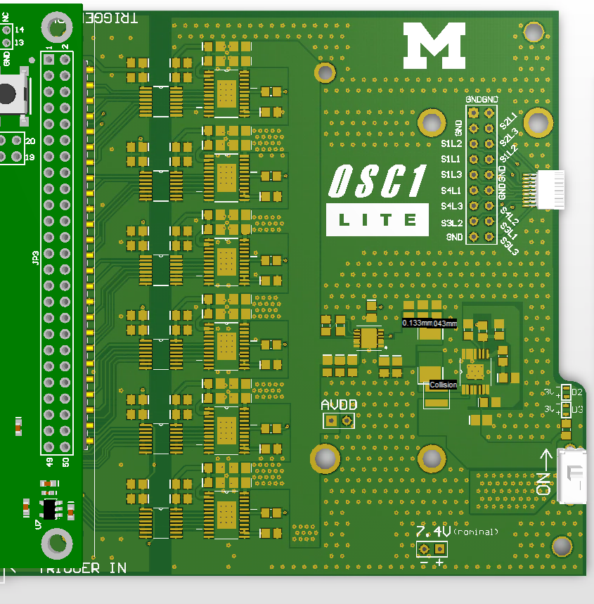

**GND**

**Point 12**

**(Every Channel)**

**> 12V**

**Point 2**

**1.2V**

**Point 3**

**14.5V**

**Point 1**

**15V**

**Point 4**

**14.5V**

**Point 5**

**(Every channel,**

**Also on back)**

**4.6V**

**Point 11**

**(Every channel,**

**Also on back)**

**> 12V**

Fig 1. Test points on the output half of the PCB

# OSC1Lite board testing checklist

☐ 1. All components are well connected to solder pads. No shorted pinouts

☐ 2.1. Supply voltage shown on the DC power source is 7.4V. Supply current is less than 0.3A

☐ 2.1. Using DC power source, the 2 green LEDs on board light up

☐ 2.2. Voltage at point 1 within range 14.25V ~ 15.75V

☐ 2.2. Voltage at point 2 within range 1.14V ~ 1.26V

☐ 2.2. Voltage at point 3 within range 13.78V ~ 15.22V

☐ 2.2. Voltage at point 4 within range 13.78V ~ 15.22V

☐ 2.2. Voltage at point 5 for all 12 channels within range 4.37V ~ 4.83V

☐ 2.3. After triggering, all 12 channels in “Open Circuit” status

☐ 2.3. Voltage at point 11 for all 12 channels are greater than 12V

☐ 2.3. Voltage at point 12 for all 12 channels are greater than 12V

☐ 2.4. Using battery, the 2 green LEDs on board light up

☐ 3.1. With 50 uA amplitude, all channels are in “Normal” status

☐ 3.1. With 100uA amplitude, trigger each channel separately, corresponding LED is flashing

☐ 3.2. With 50 uA amplitude, all channels are in “Normal” status, all uLEDs are flashing

☐ 3.2. With 100uA amplitude, trigger each channel separately, corresponding uLED is flashing